Final Project Proposal
DEPI GIZ3_AIS2_S2

Project Title:
AI-Assisted Brain Tumor Diagnosis System Using MRI and Patient Survey
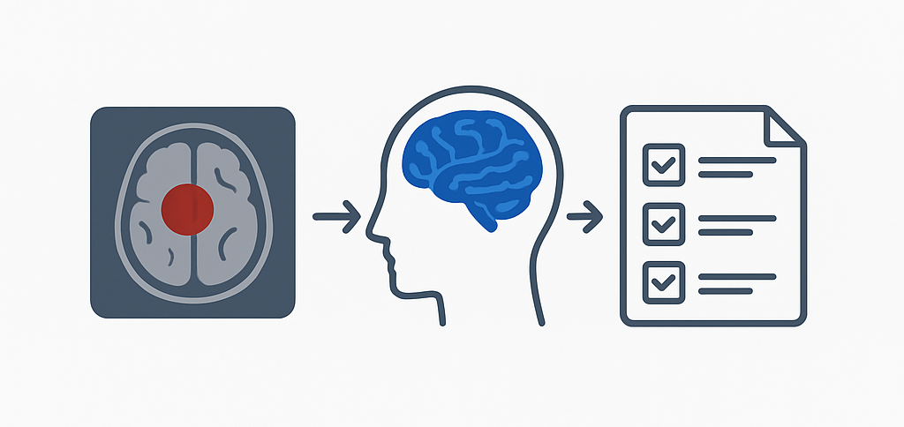

1. Project Description
This project aims to develop an AI-based diagnostic system that classifies
MRI brain scans into four categories:
Glioma, Meningioma, Pituitary, or No Tumor.
A deep learning model based on the Xception architecture was fine-tuned using a public Kaggle dataset to accurately identify tumor types from MRI images. The model leverages transfer learning to achieve high accuracy while maintaining efficiency for research and educational use.
The workflow includes data preprocessing, model training, evaluation, and result generation, all implemented and tested within a Jupyter Notebook environment. A concise implementation phase was completed to generate structured diagnostic outputs and reports for the final submission.
This project demonstrates the potential of deep learning in medical imaging, offering an automated and reliable approach for early tumor detection and classification support.
2. Group Members & Roles
Member Name | Role
Fady Morkos Farhan | Team Leader — oversees all teams, integration, and presentation
Salma El Hefny | Data & Preprocessing Team — Responsible for MRI data cleaning, resizing, normalization, and dataset structuring.
Abdallah Shehata | Data & Preprocessing Team — Handles data augmentation, dataset organization, and ensuring balanced class distribution.
Ahmed Mohamed | Image Model Team — Focuses on training and fine-tuning the Xception CNN, evaluating accuracy and model optimization.
Abdulrahman Ahmed | Evaluation & Documentation Team — Supports model performance analysis, metric reporting, and documentation preparation.
Mohamed Yousry | Evaluation & Documentation Team — Assists in compiling evaluation results, visualizing outcomes, and preparing final documentation.

3. Team Leader
Name: Fady Morkos Farhan
4. Objectives
• Develop a deep learning model using the Xception architecture for MRI brain tumor classification.
• Classify MRI scans into four categories: Glioma, Meningioma, Pituitary, and No Tumor.
• Train and fine-tune the Xception model on a Kaggle brain tumor MRI dataset for optimized accuracy.
• Evaluate model performance using accuracy, loss, confusion matrix, and classification metrics.
• Visualize results and insights within the notebook for interpretability and validation.
5. Tools & Technologies
- Languages: Python
- Frameworks & Libraries: TensorFlow, Keras, Streamlit, ReportLab
- Development Tools: Jupyter Notebook, Google Colab, GitHub
- Datasets: Kaggle Brain MRI dataset (four tumor classes: Glioma, Meningioma, Pituitary, No Tumor)
- Supporting Libraries: NumPy, pandas, scikit-learn, matplotlib, seaborn, PIL

6. Milestones & Deadlines
Phase | Task | Deadline
Phase 1 | Data collection and preprocessing from Kaggle dataset. | Week 1
Phase 2 | Model training and fine-tuning using the Xception architecture. | Week 2
Phase 3 | Model evaluation and performance visualization. | Week 3
Phase 4 | Implementation of the trained model and workflow integration | Week 4
Phase 5 | Result generation, performance reporting, and documentation | Week 5
Phase 6 | Final testing, Optimization, documentation and presentation. | Week 6

7. KPIs (Key Performance Indicators)
1. Data Quality
• Missing values: Handled during preprocessing
• Class balance: Maintained across four tumor categories
• Image size normalization: 299×299 pixels

2. Model Performance
• Base model: Xception (ImageNet weights, fine-tuned)
• Training epochs: 50
• Optimizer: Adam
• Loss: Categorical Crossentropy
• Model accuracy: ~95% (as reported in notebook results)

3. Deployment & Usability
- Output visualization: Accuracy/loss curves, confusion matrix, and classification metrics displayed within the notebook
- Model loading and prediction: Functional using saved .h5 weights
- Input format: Accepts single MRI image inputs (.jpg / .png)
- Output: Classification label and confidence score shown directly in the notebook

8. Expected Outcome
A functional prototype web app capable of diagnosing brain tumors using AI image analysis and patient survey interpretation, with strong accuracy metrics and clear medical disclaimers.
The project will serve as a demonstration of AI’s practical utility in healthcare diagnostics.

